**Om Polymers**

**Submitted by**

1. **Kakadiya kishan (42)**
2. **Kanani Nehalkumar (43)**

As a part of submission of Software Development Project Semester-5



ExternalGuide Internal Guide

Mr. Yash Prajapati Mr. Bhavik Pandya

**Navgujarat College Of Computer Application**

**Gujarat University**

**Ashram Road, Ahmedabad**

**October-2022**

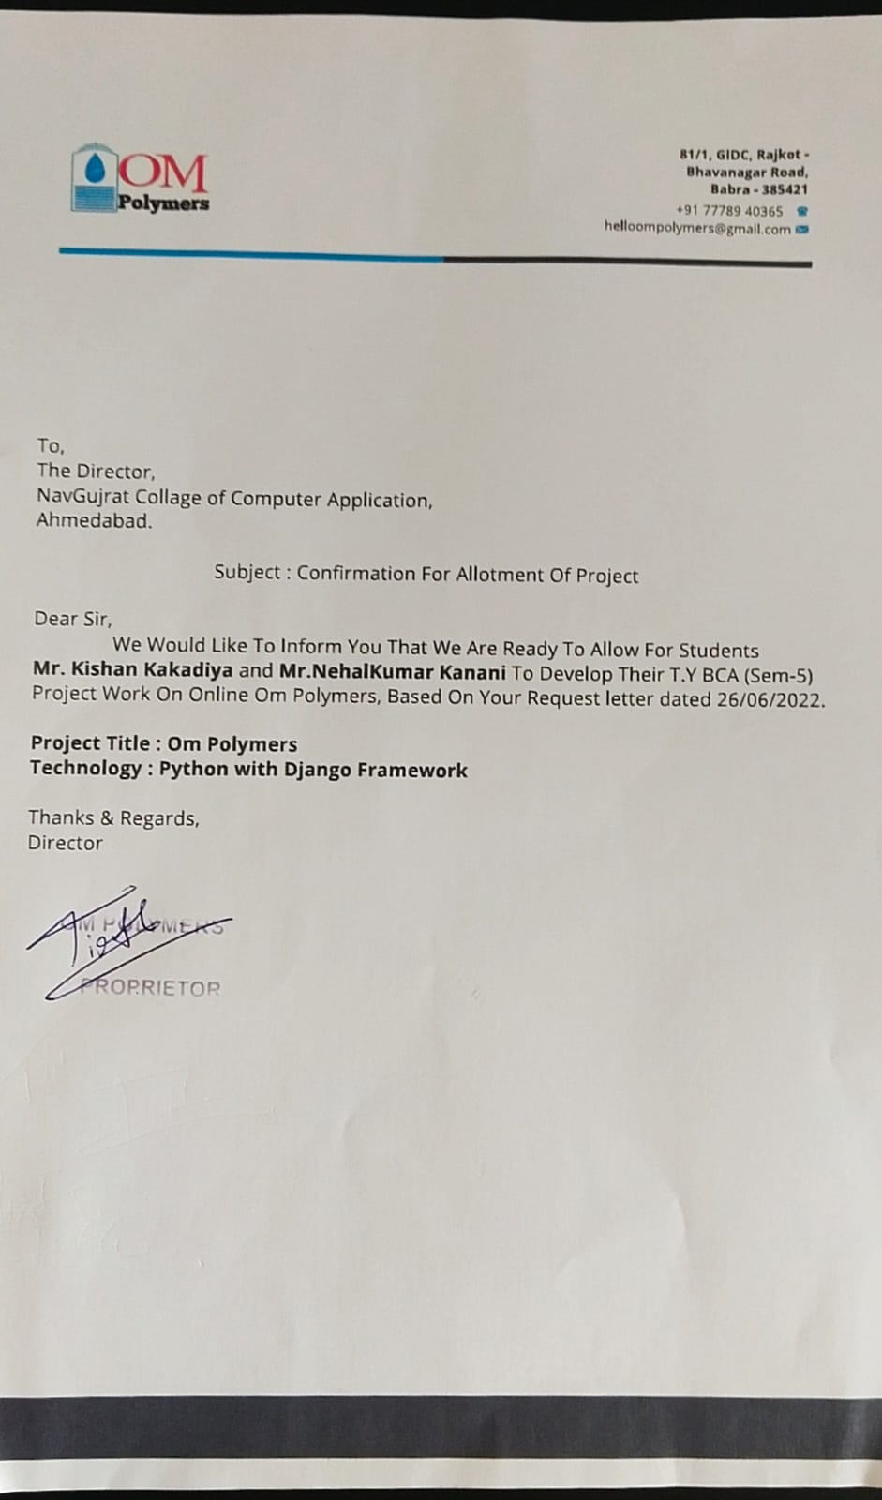

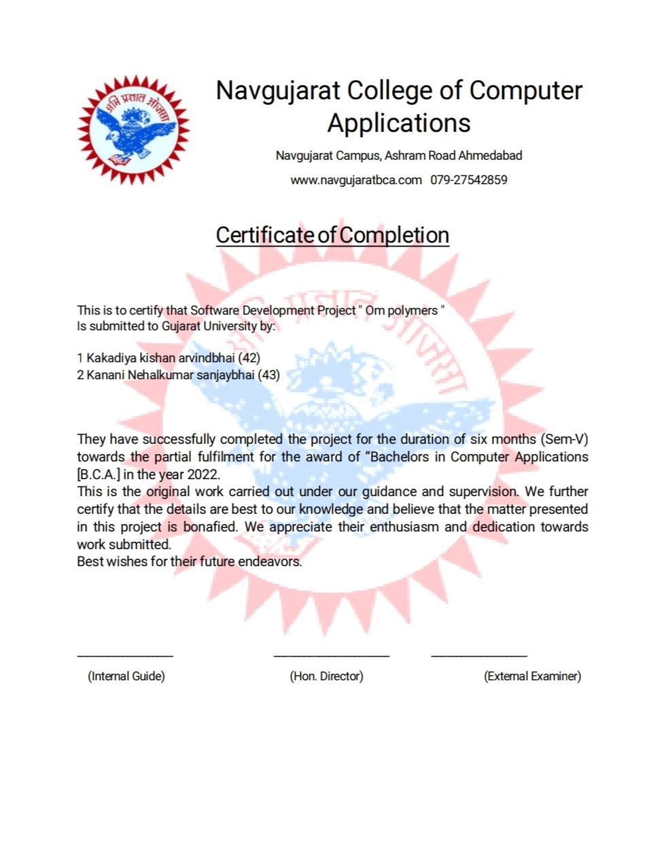

**ACKNOWLEDGEMENT**

We are very thankful to everyone who supported us for this project gave their guidance to computer and thesis work effectively and moreover on time.

We are equally grateful to our faculty who gave us moral support and guided us in different matters and solutions regarding the topic.

We feel immensely proud in extending our heartiest thanks to mr.Bhavik pandya principle of Navgujarat College, for providing us a platform to improve in various fields. They have been a source of inspiration for us and their experience and knowledge have helped us in learning and giving this project the shape it has assumed.

With Regards:

Kishan kakadiya(42)

Nehalkumar kanani(43)

**Index**

|  |  |  |
| --- | --- | --- |
| **NO.** | **TITLE** | **PAGE NO.** |
|  |  |  |
| 1 | Project profile | 6 |
| 2 | Company profile | 7 |
| 3 | Project definition | 8 |
| 4 | Existing system | 9 |
| 5 | Proposed system | 10 |
| 6 | Tools and technology | 11 |
| 7 | Modules information | 12 |
| 8 | System flow chart | 13 |
| 9 | Use case diagram | 17 |
| 10 | Sequence diagram | 21 |
| 11 | Activity diagram | 26 |
| 12 | Class diagram | 31 |
| 13 | ER diagram | 32 |
| 14 | Data dictionary | 33 |
| 15 | Bibliography | 42 |

1. **PROJECT PROFILE**

|  |  |
| --- | --- |
| Project title | Om polymers |
| Number of Member | 2 |
| Name of Members | Kishan kakadiya(42)  Nehalkumar kanani(43) |
| Project Duration | 1 year |
| Internal Guide | Mr. bhavik pandya |
| External Guide | Mr.Yash Prajapati |

1. **COMPANY PROFILE**

|  |  |
| --- | --- |
| Company Name | Om polymers |
| Company Address | 81/1, GIDC,RAJKOT-  BHAVANAGER ROAD,  BABRA – 385421 |
| Contact Person | Tirth desai |
| Contact No | +91 77789 40365 |

**3. PROJECT DEFINITION**

Om polymers is python based web application. This system where customer can buy or order water storage tanks, sewage storage tanks, Road Safety Equipment’s and quality industrial and business supplies with reasonable price. User visiting a website can see a wild range of equipment and product arrange in respective category.

Simply, both customer and shop owners do not need to touch the real products in the whole process the shopping, and management. In the end the logistic centre will distribute the product required by customers, or products ordered by shop owners to their locations.

**4. EXISTING SYSTEM:-**

* The current system of the firm is totally manual. Automation is not there. Tasks like making the sales and purchase record, for billing system, and for analysing the various task and accounts are manual and done by humans. So it requires more time, more resources, incurred more cost and more energy for completing the task.

**Problem with existing system**

* Current system is totally manual.
* Current requires more human resources for tasks.
* Current system incurred more cost
* Current system is very time consuming.
* Current system is very hard to maintain by human being.
* Report generation is also a very difficult task.

**5. PROPOSED SYSTEM (NEW SYSTEM)**

* The main objective of this system is to make the long and and time consuming buying process much easier, time saving and faster for customer. Customer can buy any product and pay money online.

**Advantage of proposed system**

* Customer can save the time.
* Customer can online payment.
* Customer can more online product then visit shop.
* We will also provide information about how to use each and every products

**6. TOOLS AND TECHNOLOGY:-**

**TECHNOLOGY:-**

1. **Frontend**

* HTML
* CSS
* JavaScript
* Bootstrap v4.1.3

1. **BACKEND**

* Python 3.10.6
* MySQL

1. **BACKEND FRAMWORK**

* Django 4.1

**TOOLS:-**

* Visual studio code
* Sublime
* Draw.io

**7. MODULES INFORMATION**

**Modules of Admin**

* Admin can login
* Admin can handle login details customer
* Admin can handle category/subcategory for the product
* Admin can handle the product details
* Admin can handle the details of products that ordered by customer
* Admin can handle the annual reports of product
* Admin can handle the advertisement details

**Modules of Customers**

* Customer can sign up and login
* Customer can get information
* Customer can place the order
* Customer can delete the order
* Customer can pay online for the order
* Customer can search products by the name , cost , etc…
* Customer can buy product and plants
* Customer can add product to a cart and wish list.

**8. SYSTEM FLOW DIAGRAM**

System flow diagram is a basically a graphical and sequential representation of the major steps involed in a systematic process.

**SYMBOLS OF SYSTEM FLOW DIAGRAM**

* **Start/end point**

**­­­**

An oval represents a start or end point. The terminator symbol marks the starting or ending point of the system. It usually contains the word “Start” or “End”.

* **Arrows**

A line is a connector that shows relationships between the representative shapes.

* **Process**

A rectangle represents a process

* **Decision**

A diamond indicates a decision. It appoints where the outcome of a decision dictates the next step. There can be multiple outcomes, but often there are just two – yes and no or true – false, then branches to different parts of the system flow diagram

* **ADMIN SYSTEM FLOW DIAGRAM**

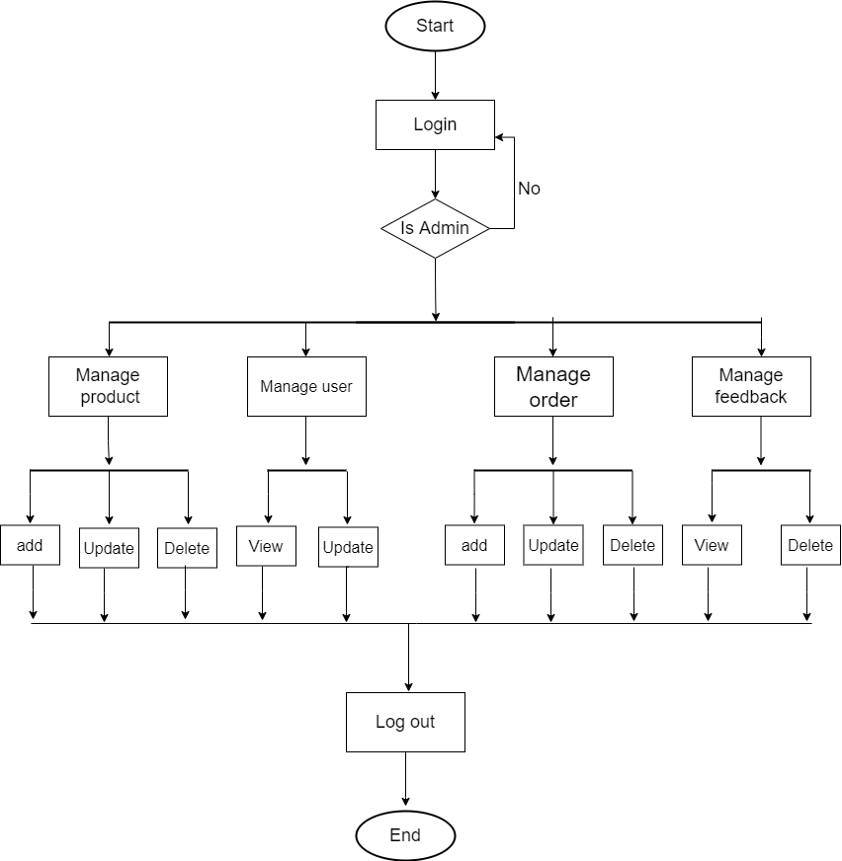

* **CUSTOMER SYSTEM FLOW DIAGRAM**

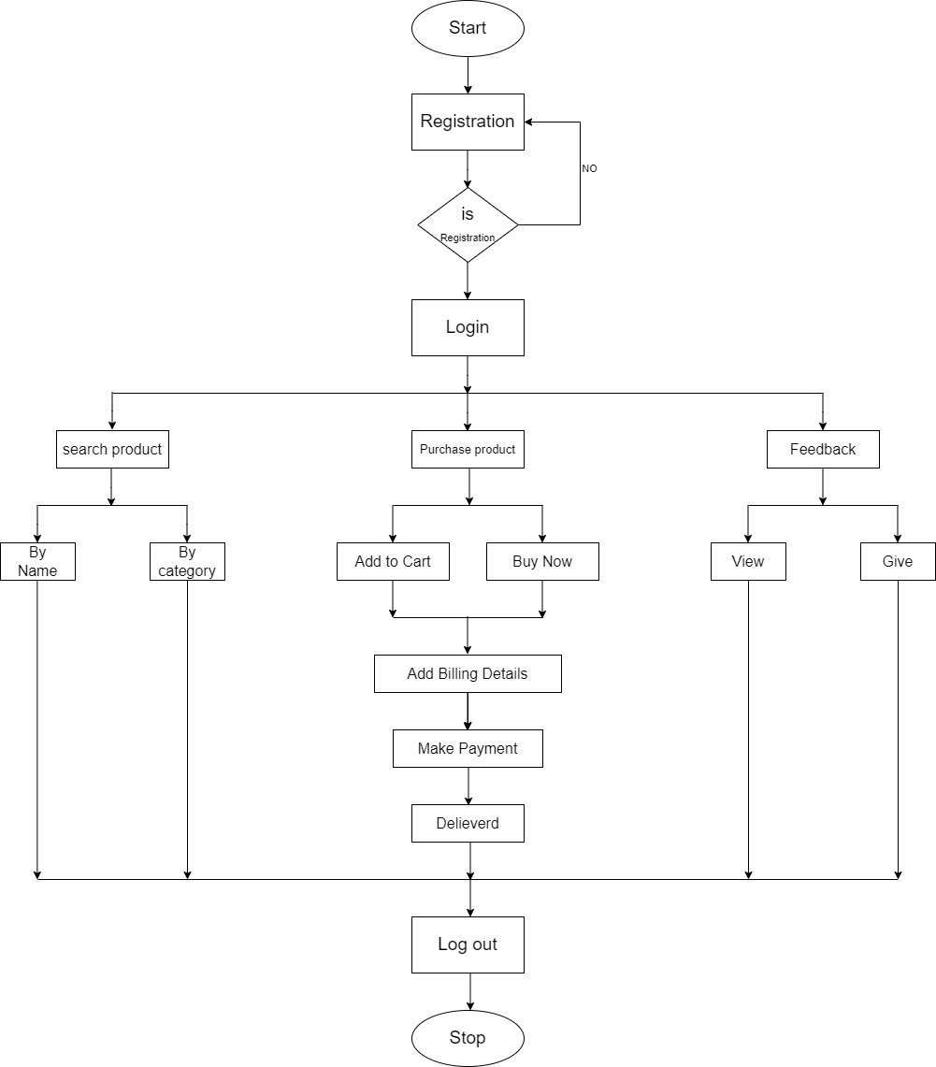

**9. USE CASE DIAGRAM**

**Symbols of use case diagram**

* **Use case**

Draw use cases using ovals. Label the ovals with verbs that represent the system’s functions.

* **Actors**

Actors are the users of a system. When one system is the actor of another system label the actor system with the actor stereotype.

* **System**

Draw the system’s boundaries using a rectangle that contains use cases, place actor outsides the system’s boundaries.

* **Relationships**

<<include>>

<<extend>>

Illustrate relationships between an actor and a use case with a simple line. for relationship among use cases, use arrows labelled either “uses” or “extends”. A “uses” relationship indicates that one use case is needed by another in order to perform a task.

An “extends” relationship indicates alternative options under a certain use case.

* **ADMIN USE-CASE DIAGRAM**

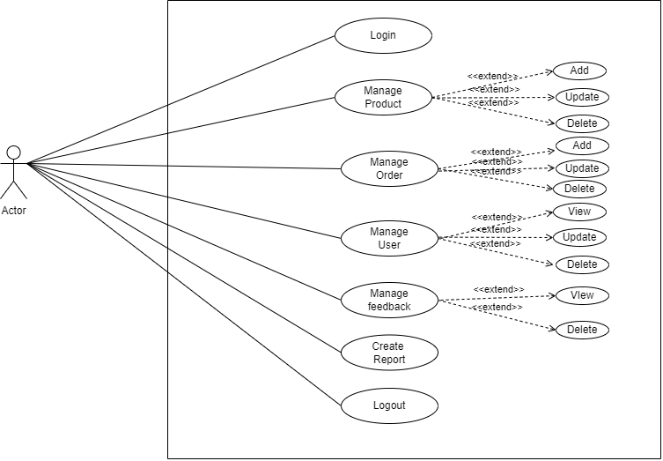

* **CUSTOMER USE-CASE DIAGRAM**

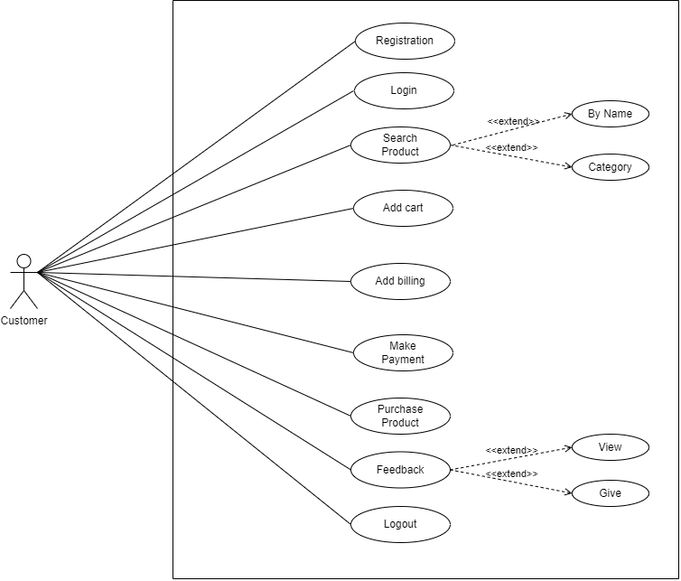

**10. Sequence Diagram**

* **Admin sequence Diagram**

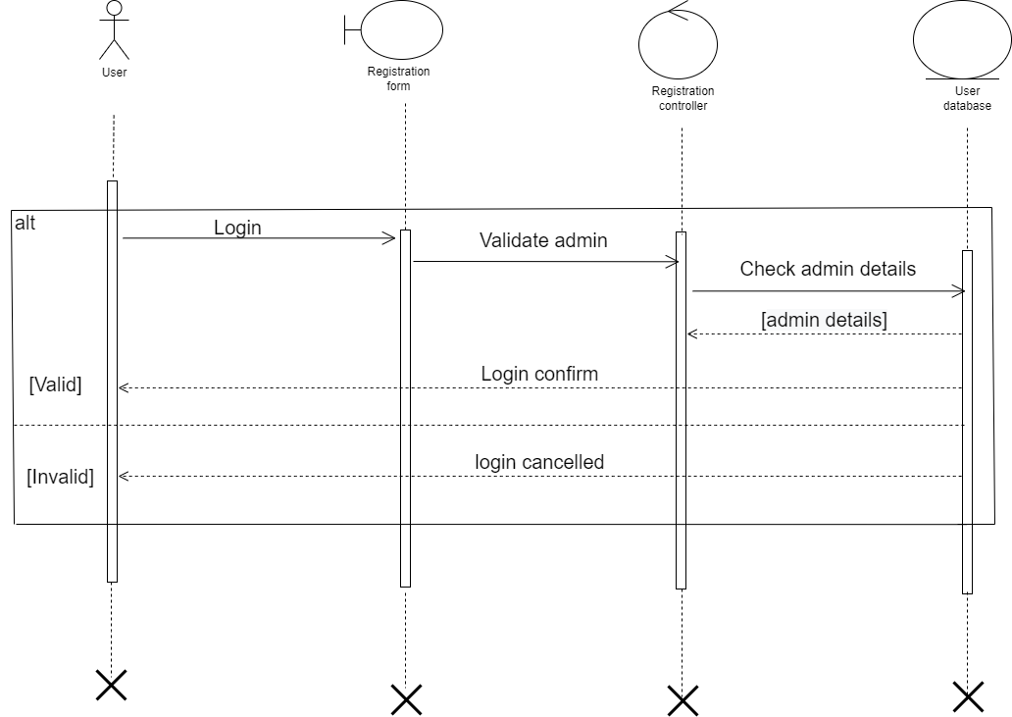

* **User registration sequence diagram**

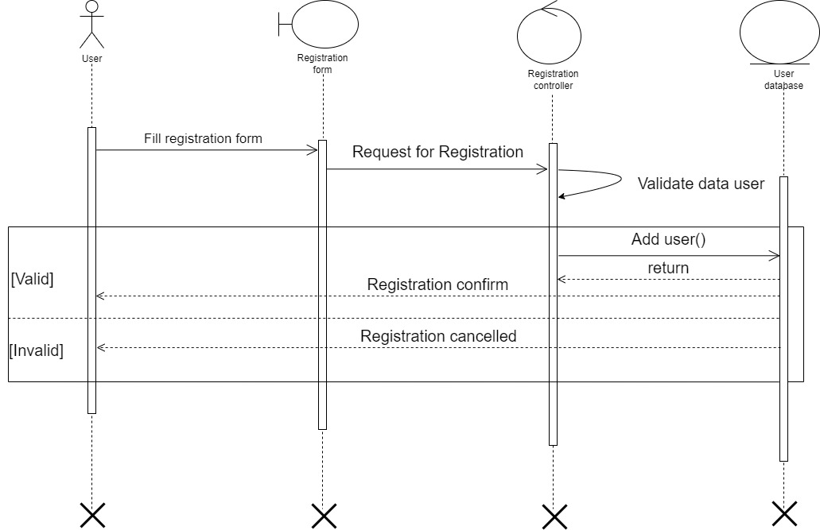

* **Order sequence diagram**

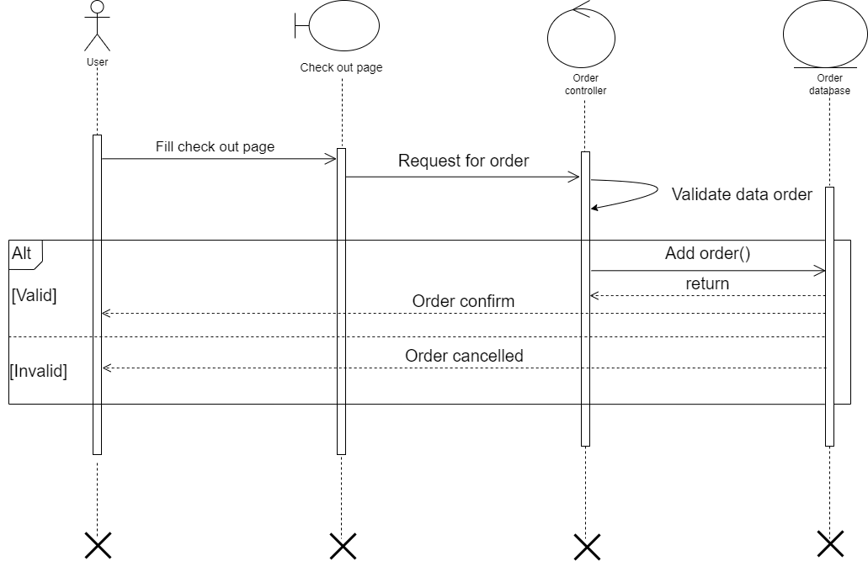

* **Add to cart sequence diagram**

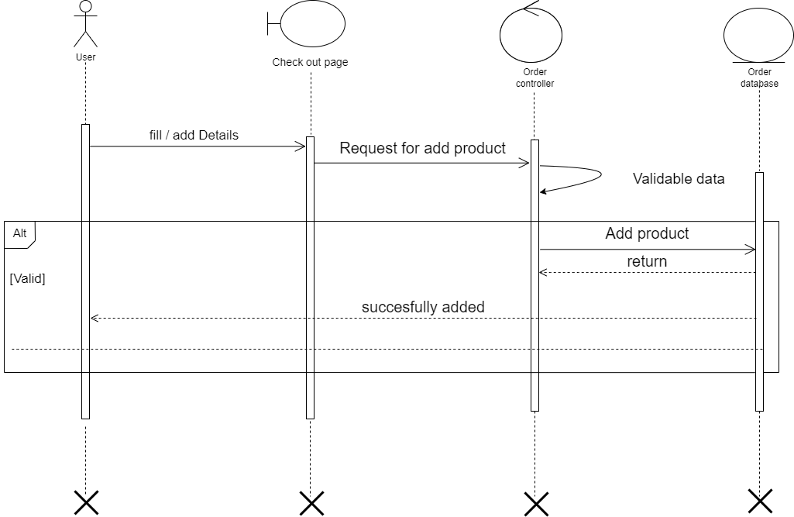

* **Feedback sequence diagram**

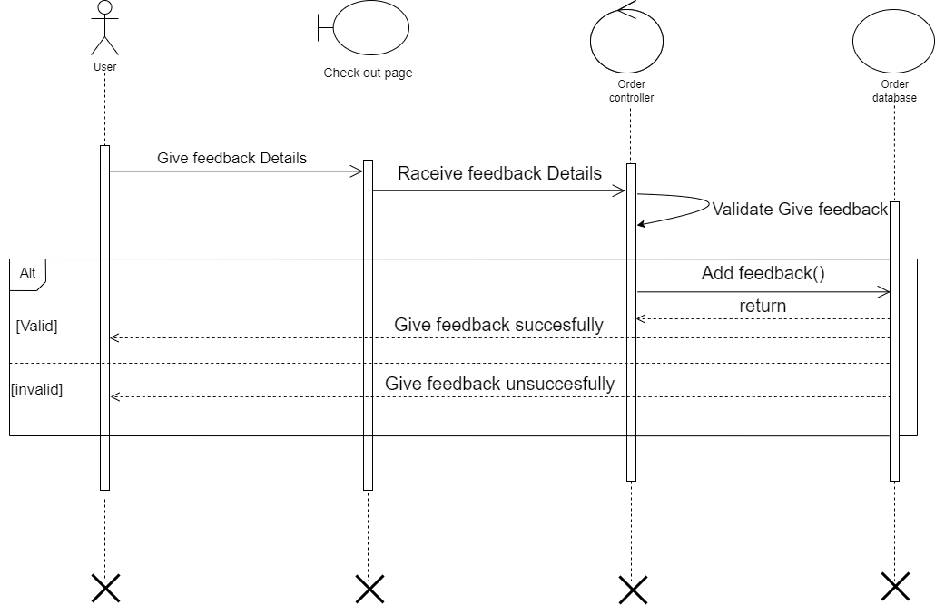

**11. ACTIVITY DIAGRAM**

* **Admin Activity Diagram**

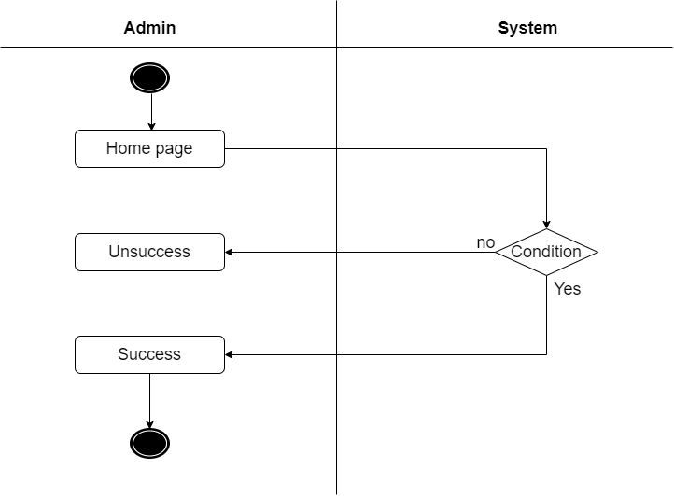

* **User Registration Activity Diagram**

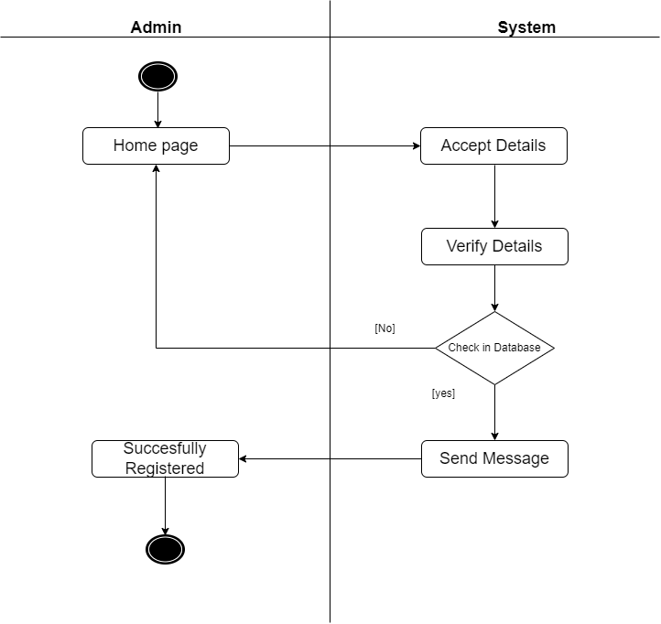

* **Order Activity Diagram**

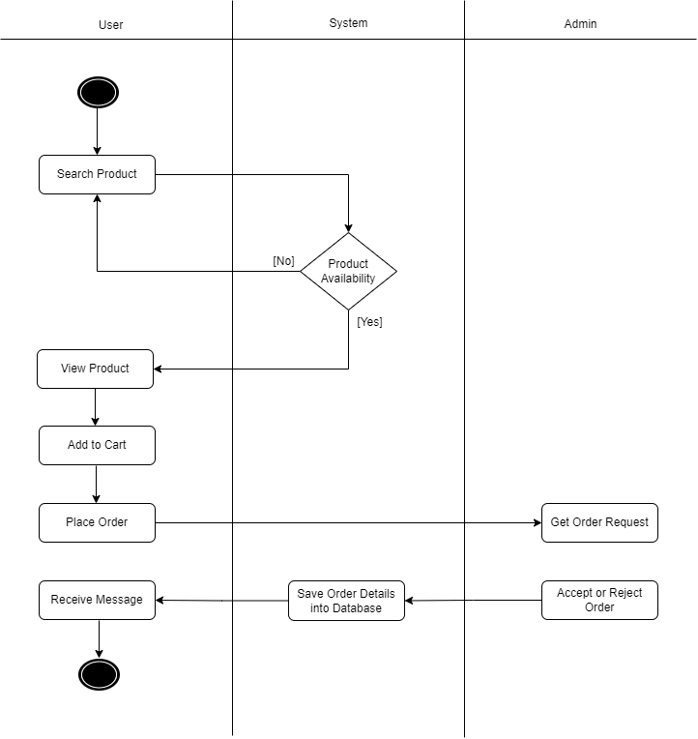

* **Cart Activity Diagram**

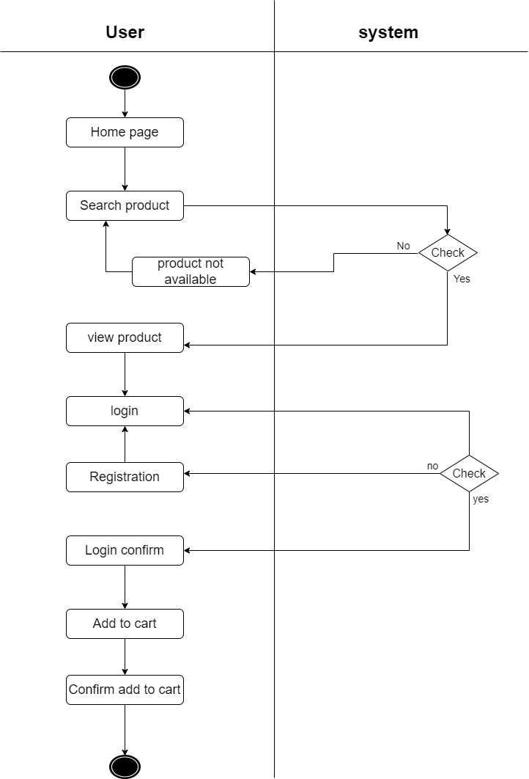

* **Feedback Activity Diagram**

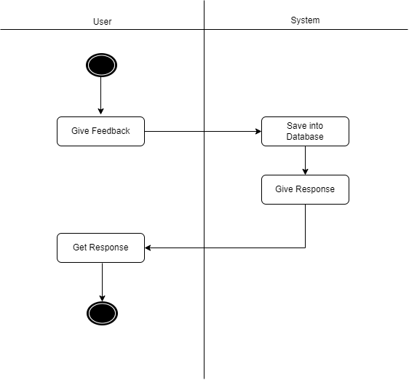

**12. CLASS DIAGRAM**

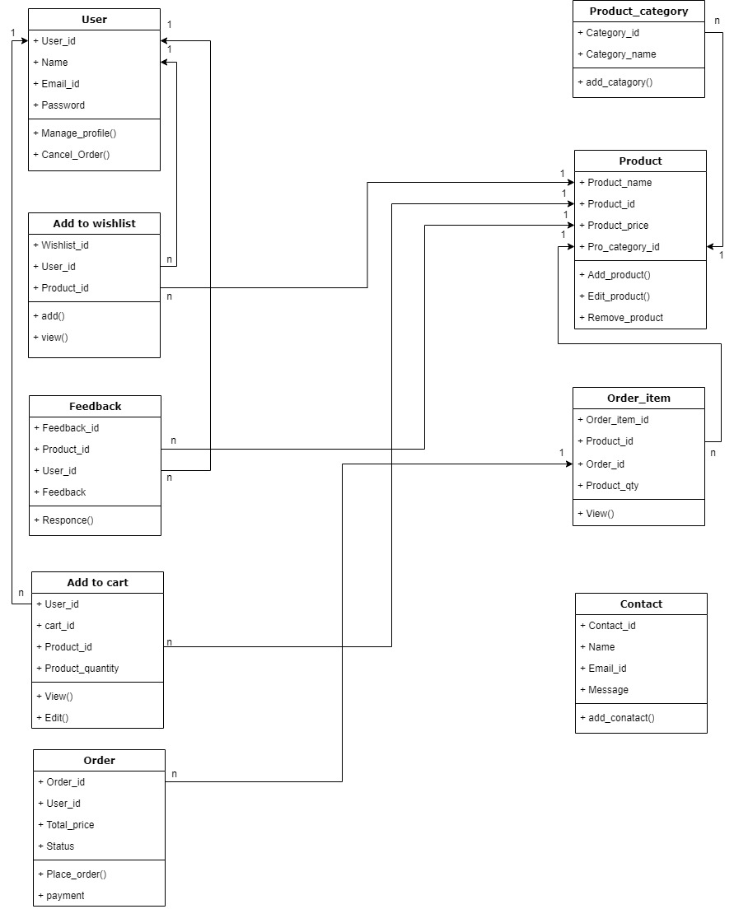

**13. ER DIAGRAM**

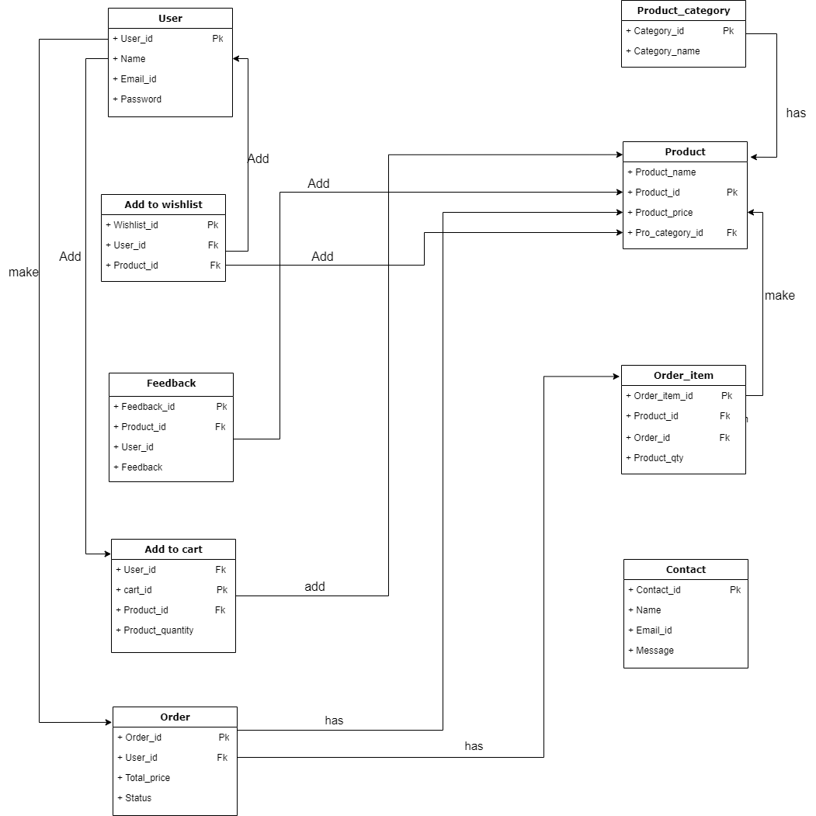

**14. DATA DICTIONARY**

* **User Table**

Table Name: User Table

Table Description: This table store user information’s.

Constraint: Primary key, unique key, Not Null

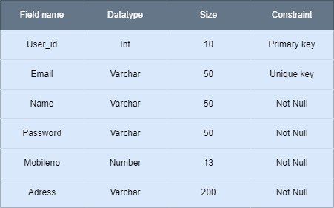

* **Product table**

Table Name: Product Table

Table Description: This table store about product information’s.

Constraint: Primary key, Foreign key, Not Null

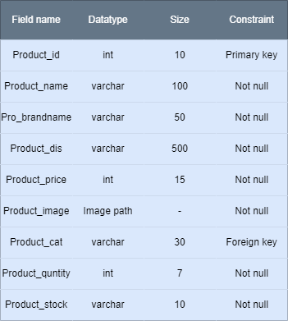

* **Product category Table**

Table Name: Product Category Table

Table Description: This table store Product category information’s.

Constraint: Primary key, Not Null

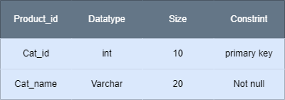

* **Add to cart table**

Table Name: Add to cart Table

Table Description: This table store cart information’s.

Constraint: Primary key, Foreign key, Not Null

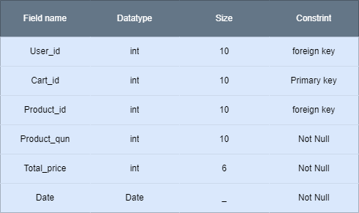

* **Order Table**

Table Name: Order Table

Table Description: This table store Order information’s.

Constraint: Primary key, Foreign key, Not Null

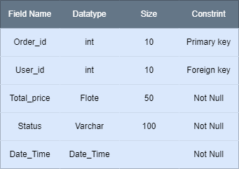

* **Order item Table**

Table Name: Order_item Table

Table Description: This table store Order item information’s.

Constraint: Primary key, unique key, Not Null

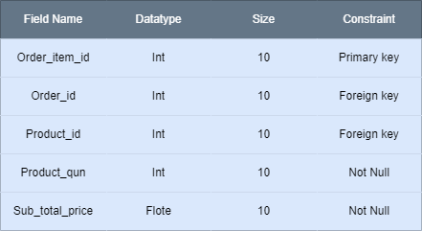

* **Wishlist Table**

Table Name: Wishlist Table

Table Description: This table store wishlist information’s.

Constraint: Primary key, Foreign key, Not Null

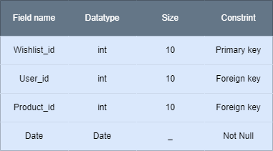

* **Contact Table**

Table Name: Contact Table

Table Description: This table store about contact information’s.

Constraint: Primary key, Not Null

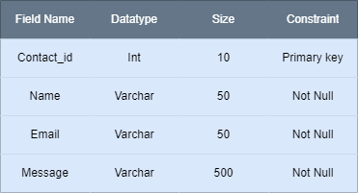

* **Feedback Table**

Table Name: Feedback Table

Table Description: This table store about feedback information’s.

Constraint: Primary key, Foreign key, Not Null

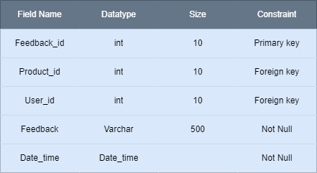

**15.Bibliography**

* [https://motorpumpkart.com](https://motorpumpkart.com/)
* [https://www.python.org](https://www.python.org/)
* <https://www.djangoproject.com>

Thank You